# **HIGHER NATIONALS - ASSESSMENT (ASSIGNMENT)**

|  |  |  |  |  |  |
| --- | --- | --- | --- | --- | --- |
| **Course Title:** | **Pearson Higher Nationals in Computing** | | | | |
| **Name of the Learner:** | Mr. / Ms. | | | | |
| **Ref. No. of the Learner:** |  | **Pearson Regd. No.:** | |  | |
| **Unit No. & Title:** | **Unit 18: Discrete Maths** | **Batch No. & Semester:** | | **CSD 7&8, Semester 03** | |
| **Assignment Parts:** | **01, 02, 03, 04** | **Name of**  **Assessor:** | **Eng. A. L. Jubailah Begum** | | |
| **Issued Date:** | **23 September 2020** |
| **Submission Date:** | **05 November 2020** | **Date Received 1st submission:** | | |  |
| **Re-submission Date:** |  | **Date Received 2nd submission:** | | |  |

|  |  |  |
| --- | --- | --- |
| **Assessor Summative Feedback:** | | |
| **Grade:** | **Assessor Signature:** | **Date:** |
| **Resubmission Feedback - Formative:** | | |
| **Grade:** | **Assessor Signature:** | **Date:** |
| **Internal Verifier’s Comments:** | | |
| **Signature of the IV:** | | **Date:** |
| **Student Agreement:**  I understand the feedback given to me and agree to carry out the actions in future works as required and indicated. | | **Student Signature:** |
| **Date:** |

**Please note that grade decisions are provisional. They are only confirmed once internal and external moderation has taken place and grades decisions have been agreed at the assessment board.**

# **Learner Assessment Submission and Declaration**

When submitting evidence for assessment, each learner must sign a declaration confirming that the work is their own.

Please list the evidence submitted for each task. Indicate the page numbers where the evidence can be found or describe the nature of the evidence (e.g. video, illustration).

|  |  |  |  |  |  |  |  |
| --- | --- | --- | --- | --- | --- | --- | --- |
| **Unit No. & Title:** | | | | | | | |
| Task | Assessment Evidence | **P** | Page No*.* | **M** | Page No. | **D** | Page No*.* |
|  |  |  |  |  |  |  |  |
|  |  |  |  |  |  |  |  |
|  |  |  |  |  |  |  |  |
|  |  |  |  |  |  |  |  |
|  |  |  |  |  |  |  |  |
|  |  |  |  |  |  |  |  |
|  |  |  |  |  |  |  |  |
|  |  |  |  |  |  |  |  |
|  |  |  |  |  |  |  |  |
|  |  |  |  |  |  |  |  |
|  |  |  |  |  |  |  |  |
|  |  |  |  |  |  |  |  |
|  |  |  |  |  |  |  |  |
|  |  |  |  |  |  |  |  |
|  |  |  |  |  |  |  |  |
|  |  |  |  |  |  |  |  |
|  |  |  |  |  |  |  |  |

|  |
| --- |
| Additional comments to the Assessor: |

# **Plagiarism**

Plagiarism is a particular form of cheating. Plagiarism must be avoided at all costs and students who break the rules, however innocently, may be penalised. It is your responsibility to ensure that you understand correct referencing practices. As a university level student, you are expected to use appropriate references throughout and keep carefully detailed notes of all your sources of materials for material you have used in your work, including any material downloaded from the Internet. Please consult the relevant unit lecturer or your course tutor if you need any further advice.

|  |
| --- |
| **Learner declaration**  I certify that the work submitted for this assignment is my own. I have clearly referenced any sources used in the work. I understand that false declaration is a form of malpractice.  Learner Signature: Date: |

# 

# **Assessment Tracking**

|  |  |  |  |  |  |
| --- | --- | --- | --- | --- | --- |
| **Assessment Record And Feedback Sheet** | | | | | |
| **Programme:** | HND Computing | **Student Name:** |  | | |
| **Unit No. & Title:** | Unit 18: Discrete Maths | **Assessment Date:** |  | **Unit Grade:** |  |
| **Assessor Name:** | Eng. A.L. Jubailah Begum | **Completion Date:** |  | **IV Signature:** |  |

|  |  |  |  |  |  |  |
| --- | --- | --- | --- | --- | --- | --- |
| **Assignment (Parts)** | **Learning Objectives** | **Criteria Targeted** | **Date Issued** | **Hand In Date** | **Formative**  **Feedback** | **Resubmission Date\*** |
| **01** | LO1 Examine set theory and functions applicable to  software engineering | P1, P2  M1  D1 |  |  |  |  |
| **02** | LO2 Analyze mathematical structures of objects  using graph theory | P3, P4  M2  D2 |  |  |  |  |
| **03** | LO3 Investigate solutions to problem situations using the application of Boolean algebra | P5, P6  M3  D3 |  |  |  |  |
| **04** | LO4 Explore applicable concepts within abstract  algebra | P7, P8  M4  D4 |  |  |  |  |

|  |  |  |  |
| --- | --- | --- | --- |
| **Assignment (part) No.** | **Grading Criteria** | **Summative Comments** | **Assessor Signature** |
| **01** | **P1** |  |  |
| **P2** |  |  |
| **M1** |  |  |
| **D1** |  |  |
| **02** | **P3** |  |  |
| **P4** |  |  |
| **M2** |  |  |
| **D2** |  |  |
| **03** | **P5** |  |  |
| **P6** |  |  |
| **M3** |  |  |
| **D3** |  |  |
| **04** | **P7** |  |  |
| **P8** |  |  |
| **M4** |  |  |
| **D4** |  |  |

|  |  |  |  |  |  |
| --- | --- | --- | --- | --- | --- |
| **Unit Review Plan** | | | | **ISVU 2014 Rev 1.0** | |
| **Assignment** | **Task** | **Evidence** | **Formative Comments** | | **Date** |
| **01** | 1.1 | Report |  | |  |
| 1.2 | Report |  | |  |
| 1.3 | Report |  | |  |
| 1.4 | Report |  | |  |
| 1.5 | Report |  | |  |
| **02** | 2.1 | Report with detailed diagrams |  | |  |
| 2.2 | Report with detailed diagrams |  | |  |
| **03** | 3 | Report with diagram and truth table |  | |  |
| **04** | 4.1 | Report |  | |  |
| 4.2 | Report |  | |  |

**Learning Outcomes and Assessment Criteria**

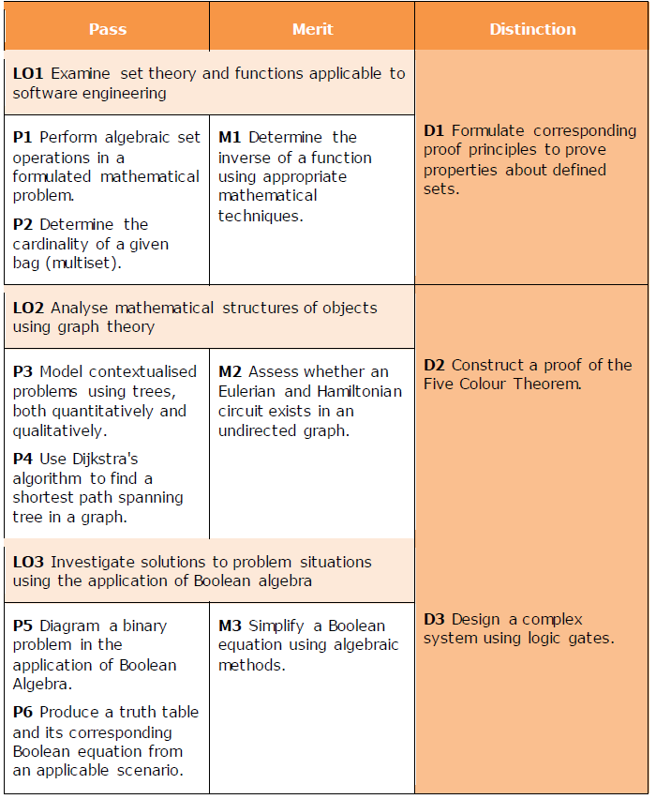

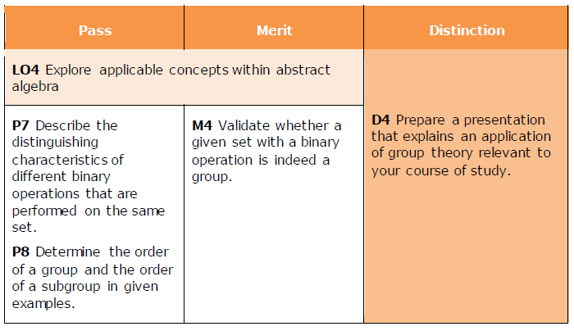

**Scenario:**

Digital computer technologies operate with distinct steps, and data is stored within as separate bits. This method of finite operation is known as ‘discrete’, and the division of mathematics that describes computer science concepts such as software development, programming languages, and cryptography is known as ‘discrete mathematics’.

This branch of mathematics is a major part of computer science courses and ultimately aids in the development of logical thinking and reasoning that lies at the core of all digital technology.

This assessment expects students to understand the discrete mathematical principles and theory that underpin software engineering. Through a series of case studies, scenarios and tasked-based assessments students will explore set theory and functions within a variety of scenarios; perform analysis using graph theory; apply Boolean algebra to applicable scenarios; and finally explore additional concepts within abstract algebra.

Among the topics included in this unit are: set theory and functions, Eulerian and Hamiltonian graphs, binary problems, Boolean equations, Algebraic structures and group theory.

On successful completion of this assessment students will be able to gain confidence with the relevant discrete mathematics needed to successfully understand software engineering concepts. As a result, they will develop skills such as communication literacy, critical thinking, analysis, reasoning and interpretation, which are crucial for gaining employment and developing academic competence.

# **Tasks**

**PART 1**

**Task 1.1**

If A = {2, 3, 4, 5}     B = {4, 5, 6, 7}     C = {6, 7, 8, 9}     D = {8, 9, 10, 11}, **Perform** the following **algebraic set operations**.   
  
(a) A ∪ B (e) (A ∪ B) ∪ C  
  
(b) A ∩ B (f) A ∪ (B ∩ C)  
  
(c) B ∪ C (g) B ∪ (C ∪ D)  
  
(d) C ∩ D (h) A - B  
  
  
**Task 1.2**

If A and B are two sets such that A ⊂ B, then what is A∪B?

**Task 1.3**

Find the union, intersection and the difference (A - B) of the following pairs of sets.  
  
(a) A = The set of all letters of the word FEAST   
  
     B = The set of all letters of the word TASTE   
  
(b) A = {x : x ∈ W, 0 < x ≤ 11}   
  
     B = {x : x ∈ W, 5 < x < 12}   
  
(c) A = {x | x ∈ N, x is a factor of 12}   
  
     B = {x | x ∈ N, x is a multiple of 2, x < 12}   
  
(d) A = The set of all even numbers less than 14   
  
     B = The set of all odd numbers less than 13

(e) A = {a, l, m, n, p}   
  
    B = {q, r, l, a, s, n}

**Task 1.4**

Let ξ = {1, 2, 3, 4, 5, 6, 7} and A = {1, 2, 3, 4, 5} B = {2, 5, 7} show that   
  
 (a) (A ∪ B)' = A' ∩ B'  
  
 (b) (A ∩ B)' = A' ∪ B'  
  
 (c) (A ∩ B) = B ∩ A   
  
 (d) (A ∪ B) = B ∪ A

**Task 1.5**

Given than A = {a, b, c, d}. Using the knowledge that you have in **determining the** **cardinality**, write down the power set of A.

**Task 1.6**

**Determine the inverse of** following **functions using appropriate mathematical techniques**.

1. *f(x) = 3x – 5*
2. g(x) = x3 – 7
3. h(x) = (x + 2)/(x-3)
4. i(x) = √(x + 2)

**Task 1.7**

**Prove** the followings using set identity. Use the knowledge of Venn diagram.

(a) B ∪ (ø ∩ A) = B

(b) (A ′ ∩ U) ′ = A

(c) (C ∪ A) ∩ (B ∪ A) = A ∪ (B ∩ C)

(d) (A ∩ B) ∪ (A ∩ B ' ) = A

(e) A ∩ (A ∪ B) = A

**Part 2**

**Task 2.1**

**Find** the **shortest path** between A to Z **using Dijkstra's algorithm** in the diagram given below.

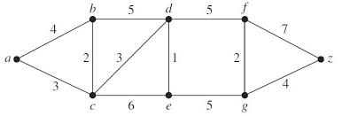

**Task 2.2**

**Access whether an Eulerian and Hamiltonian circuit exists in** the below **undirected graphs**.

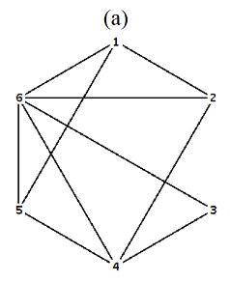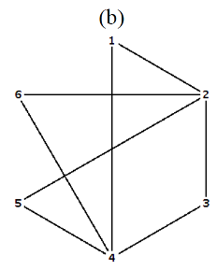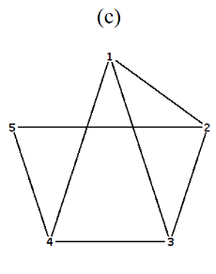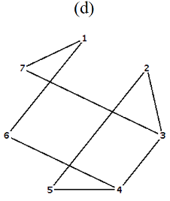

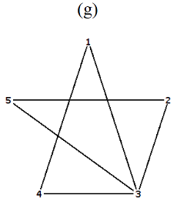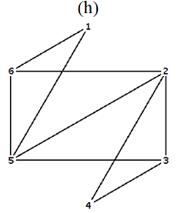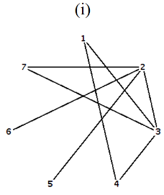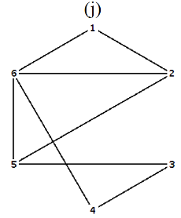

**Task 2.3**

**Construct a proof of the Five Color Theorem**. Utilize the theory of the ‘chromatic number’.

**Part 3**

**Task 3.1**

A fan in a room can be on (1) or off (0). A control system is required to operate the fan efficiently with the following conditions / functionalities.

1. The fan can manually be switched on or off.

2. The timer will be either on or off.

3. The sensor will detect whether the environment is cold or hot.

4. The fan will automatically be switched on when the timer is on and the sensor indicates the environment is hot.

The following table assigns Boolean values for the above conditions / functionalities

|  |  |
| --- | --- |
| **Condition / functionality** | **Boolean value** |
| Fan switched on manually | 1 |
| Fan switched off manually | 0 |
| Timer is on | 1 |
| Timer is off | 0 |
| Sensor detects cold environment | 1 |
| Sensor detects hot environment | 0 |

1. Produce a truth table to represent the functionality of the above system.
2. Write the corresponding Boolean equation/ expression to represent the truth table constructed in the (a) above.
3. Draw a simple logic circuit by using a combination of only the basic gates to implement the above control system which is a diagrammed binary problem in the application of Boolean Algebra.

**Task 3.2**

**Simplify** the following **Boolean equation using algebraic methods** and Boolean laws.

1. ACC + (A + A’) C + ABC
2. AA’ + BC + ABC
3. (A + B + B) (A + A’) (AA + (B’)’) + CC’

**Task 3.3**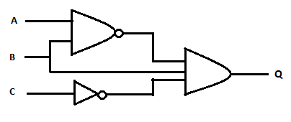

Given above a complex logic circuit system created with NAND, NOT and AND gates according to the below given scenario.

* There are three conditions provided for the inputs of the circuit system. A lamp has been fixed at the output.
* At one of the combinations of the input conditions only, the lamp will work.

Provide the Boolean Expression and the corresponding truth table for the above circuit system which satisfies the above mentioned scenario.

**Part 4**

**Task 4.1**

When considering the **set of all the natural numbers (ℕ)**, show whether the mathematical operations of **addition, subtraction, multiplication and division** are:

1. Associative binary operation
2. Commutative binary operation

**Task 4.2**

1. Describe the definition for ‘**Group**’ along with its properties.
2. Validate that the **set** of non-zero real numbers with the **operation** **of multiplication** is a commutative **group**.

**Task 4.3**

You are required to **prepare a** 15-minutes **presentation** aimed towards new students engaged under a technology company’s graduate scheme.

Your presentation will include evidence of:

An explanation that adequately explains why group theory is taught to computing students.

**NOTE:**

* This assessment brief should be attached with your answers when you submit your final report.
* If the assignment is submitted after the extended deadline, the assignment will not be accepted whereas you shall be asked to go for a **NEW assignment**.

**Instructions to students:**

1. All assignment should comprise of the standard **Front page** given**. No other front page will be accepted.**
2. All assignment should be bound with **transparent board** as the front cover and **BLACK hard board cover** asthe last sheet**.**
3. Clearly label the **CDs** with your **Name, Batch** **No**. and **Student NO** and attach it to the back cover of your assignment.
4. **Report Writing Guidelines:**
5. Every Assignment should have an **Introduction** and **Conclusion.**
6. The standard **Table of Contents** should be generated.
7. All the **Figures, Tables, Diagram** etc. should be numbered.
8. **Main Heading:** Font: **Arial**; Size 16
9. **Sub heading:** Font**: Arial;** Size 14
10. **Body text:** Font: **Arial**; Size 11
11. **Paragraph:** Single line
12. **Margins:** **Top: 1” Bottom: 1” Left: 1” Right: 1”**
13. **Header –** include the module name on the right-hand side
14. **Footer –** include the page number on the right-hand side
15. All sections should have continuity and pages should be clearly ladled.
16. **References –** clear references for all the materials, books, articles, website etc. should be given in the following format:

* **Books –** Title, Author, ISBN No, Publisher & Edition, Chapter & Page Nos.
* **URL:** Complete address e.g. http://www.abs.com/index/1234/xyz/.asp. and Date
* **Article, Journals:** Name of published material, Date, Author